CV
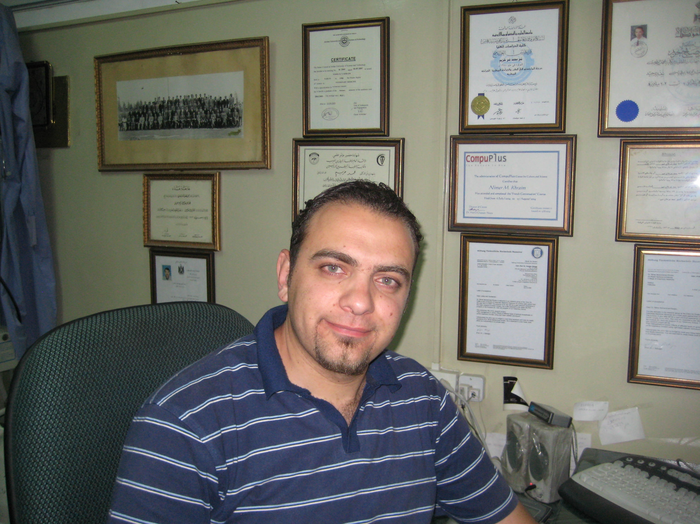

Name: Nimer Mohammad Khraim
Date of Birth: 09/02/1980
Place of Birth: Nablus -Palestine
Nationality: Palestinian
I.D. No.: 907567887
Martial Status: Single.
Residency: Nablus-Palestine
Tel. No.'s:
Mobile:+972-59-9588542
Home:+972-9-2377080
Email: nkhraim@najah.edu
pelink1980@yahoo.com

Educational Background:
Year | Education | Institution | Average | Qualification
1998 | Tawjihi-scientific | Islameyya Secondary School | 91.2 | Excellent
2003 | Bachelor's Degree in Veterinary Medicine | Mousel University- Iraq | 74.8 (level 8 of 58 students) | Good
2005 | Master Degree in Veterinary Surgery | Jordan University of Science and Technology - Jordan | 88 (level 1 of 15 students) | Very Good

Working Experience:
- 2005- Till Now: An-Najah National University Working as an instructor at College of Vet. Medicine
- 2006- Till Now: Faculty board member of veterinary medicine at An-Najah National University
- 2006- Till Now: Member of the Council of An -Najah National University
- 2007- Till Now: Instructor in Brooke institute ( healthy working animals for the worlds poorest communities)
- 2005 -Till Now: Working as Head of Vet. Surgeon at Khraim Vet. Medical Surgical Center, Nablus-West Bank, Palestine (Tel:+972-9-2378258)
- 2006- Till Now: supervisor of artificial insemination project in Awassi ewes in Palestine which funded by Perez-guerrero trust fund.
- 2003-till now: member of Jordanian veterinary association
- 2003-till now member of Palestinian veterinary association
- 2003- till now member of general federation of Arab Veterinarians
- 2004 -2005: Jordan University of Science and Technology \ Jordan: Working as a Teaching and Research Assistant in faculty of veterinary medicine and veterinary health centre.

Selected publications
€ Z. A. BANI ISMAIL, M. F. AL-ZGHOUL, A. M. AL-MAJALI & N. M. KHRAIM. BJVM, 10, No 1. 1311-1411"Effect of Early Age Castration on Penile, Urethral and Accessory Sex Glands Development on Awassi lamb

Languages:
Language | Reading | Writing | Conversation
Arabic | Excellent | Excellent | Excellent
English | Very Good | Very Good | Very Good
French | Good | Fair | Fair

Other Skills:
- Ability to work under pressure
- Ability to work within a team
- Report writing skills
- Valid driving license
-  Good computer skills

References:

  - Dr. Mohammad Khraim;
Head of Khraim Vet. Medical Surgical Center. Nablus-West Bank, Palestine
Head of Palestinian Vet. Syndicate
Assistant of Head of World Vet. Association for Planning
Mobile: +970-59-9887580

  - Dr. Zuhair Malkawi:
Assistant Prof. for Vet. Surgery at college of Vet. Medicine, Jordan University of Science and Technology ï¿½ Jordan
Head of Vet. Health Center at Jordan University of Science and Technology ï¿½ Jordan

  - Dr. Ahmad Al-Majaly:
Head of Vet. Clinical Dept., Jordan University of Science and Technology ï¿½ Jordan

  - Dr. Ibrahim Al-Zuhair, teacher of pharmacology and toxicology, college of veterinary medicine, An-Najah National University

